**CHAPTER ELEVEN**

**SET – PART ONE**

A set is defined as a collection of items

The Number System:

1. Our number system can be divided into the following group of set of numbers.(1) The Set of integers i.e. {……. -3,-2,-1,0,1,2,3,…… }.

– Integers refer to negative and positive whole numbers as well as zero.

2) The set of whole numbers i.e. {0, 1,2,3,4……….}. – Whole numbers are numbers which are greater than zero, including zero itself.

3) The set of natural or counting numbers i.e. {1, 2,3,4,5 …..}.

– Natural numbers are number from 1 upwards.

4) The set of odd numbers i.e. {1, 3,5,7,9 ….}.

- Odd numbers are those numbers, which when divided by 2 always give us a remainder or a decimal, but 1 is an odd number.

5) The set of prime numbers i.e. {2, 3, 5, 7, 11, 13, 17…..}.

– Prime numbers are those numbers which have only two factors. Since 7 has two factors which are 1 and 7, then it is a prime number.

– On the other hand, 9 = 3 $×3$ and 9 = 1 $×9⇒9$ has four factors, which are 3and 3, as well as 1 and 9. For this reason it is not a prime number.

6) The set of composite numbers i.e. {4, 6, 8,9,10 …..}.

– These are numbers which have two or more factors apart from itself and 1. For example apart from 1 and 20, 20 which is a composite number has four other factors which are {4 , 5} and {2, 10}.

– Also apart from 1 and 6, 6 which is a composite number has two other factors which are 2 and 3.

7) The set of even numbers i.e. {2, 4,6,8,10,12 ……}. – These are those numbers, which can be divided by 2 without a remainder or a decimal.

8) The set of irrational numbers i.e.

{$…..π, \sqrt{3, }\sqrt{5}$, $\frac{1}{3}$, $\frac{2}{6}$, ……..}.

– This consists of square roots of numbers which does not give us whole numbers, as well as fractions without specific values. For example $\frac{1}{3}$ = 0.333333 …… and

- Lastly π or pie, even though taken to be = ${22}/7$ or 3.14, really has no fixed value.

10) Set of real numbers i.e. {…..-3,-2,-1, 0,1,2,3.5, $\sqrt{7}$…..} ,which consists of all the various sets just discussed.

**FACTORS OF A GIVEN NUMBER:**

- These are whole numbers which can divide that given number, without any remainder, with the given number being the highest factor. Examples are;(1). The factors of 6 = 1,2,3,6 ( 2) The factors of 8 = 1,2,4,8 (3) The factors of 30 = 1, 2, 3,5,6,15,30.

**MULTIPLE OF A GIVEN NUMBER:**

- If y is our number, then the multiples of y= 1 $×y,$ 2 $×y, 3×y, 4×y……$ = y, 2y, 3y, 4y; For example, the multiples of 2= 2 $×1, 2×2,$ 2 $×3, 2×4, 2×5……………= 2, 4, 6, 8, 10……$ Also the multiples of 5 = 5 $×1, 5×2, 5×3, 5×4….$ = 5, 10, 15, 20, 25 ………………

Q1. Find the set of natural numbers from 1 to 12. Soln The set of natural numbers from1 to 12= {1,2,3,4,5,6,7,8,9,10,11,12} or {1,2,3,4, . . . . . . . . . . . 12}.

Q2. Find the set of the even natural numbers from 1 to12.

NB: First find the set of natural numbers from 1 to 12, and select the even ones among them.

Soln

$⇒$ {Natural numbers from 1 to 12} = {1, 2, 3 ………12}.

$⇒\{$ Even natural numbers} = {2,4,6,8,10,12}.

Q3. Determine the set of the multiples of 3, which are less than 15.

Soln

{Multiples of 3 less than 15} = {3,6,9,12}.

Q4. Find the set of the odd multiples of 3 up to 18. Soln

The multiples of 3 up to 18 = {3,6,9,12,15,18} and select the odd ones among them $⇒\{$ Odd multiples of 3 upto 18} = {3, 9, 15}.

**The Number of Elements:**

The number of elements of a set A is written as n(A). Therefore if A = {a,b,c}, then n(A) = 3 and also if Y= {1,2}, then n(Y) = 2.

**Types of Sets:**

There are various types of sets and these are : **1. A Finite set:**

- This is a set whose members can be counted, and an example is the set of people within a family.

**2. An Infinite set:**

- This is a set which contains an uncountable number of items or elements.

- An example is the set of the number of buckets of water that can be fetched from the sea.

**3. Equal Sets:**

- If A= [ 1,2,3} and B = {2,3,1}, then A and B are said to be equal sets.

– Two sets are said to be equal, if they contain the same elements or items, no matter the order or manner in which they have been arranged.

- Also if Z= {a,b,c,d} and X = { b,a,c,d}, then Z and X are equal sets.

**4. Equivalent sets:**

- These are two sets, in which the number of items or elements found in each is the same.

- For example if X = {a,b} and Y= {1,2), then X and Y are equivalent sets.

**5. The Null Set:**

- This is a set which has no members, and it is represented by the symbol { } or Ø.

– For example {People who live in the sea} = Ø.

**6. Disjointed Sets:**

- These are two sets which do not contain any element in common.

– Example 1. If A = {1,2,3} and B = {5,9}, then A and B are disjointed sets, which can be represented on a Venn diagram as shown next:

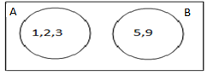

Example 2

If X = {a,b,c,d} and Y= {g,f,k}, then X and Y are disjoined sets which can be represented on a Venn diagram as

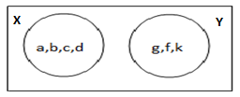

**7Jointed Sets**:

- Theses are two sets which contain one or more elements in common.

Example (1):

If x = {1, 2, 3} and Y = {2, 5}, then X and Y are jointed sets, which can be represented on a Venn diagram as:

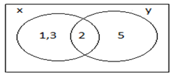

- Example 2.

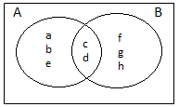If A = {a,b,c,d,e} and B = {c,d,f,g,h}, then A and B are jointed sets, which can be illustrated on a Venn diagram as:



**8) The Universal Set:**

- This is represented by the symbol or U. It is a set which is always bigger than the set under consideration. For example if our set under consideration is {Fantis}, then any of the following sets can be Chosen as the universal set: A = {Akans}, B = {Ghanaians} and C= {Africans}. - Also if our set under consideration is {1,2}, then any of the following sets can be chosen as the universal set: A = {1,2,3}, B = {1,2,3,4,5}, C = {Integers} and D = {Whole Numbers}.

**9) Subset:**  - If A = {1,2,3} and B = {2,3}, then we say that B is a subset of A, which is written as B $⊂$ A or A $⊃$ B. For B to be a subset of A, then(i). All the members of B must also be members of A.

(ii). The set A must contain one or more elements which are not found in B.

Example 1.

If Z = {1,2,3,4,5} and W ={2,5}, then W $⊂$ Z.

Example 2. - If Y = {a,b,c,d,e} and x = {b,d,e}, then X $⊂$ Y.

- But if A = {1,3,7} and B = {3,8}, then B is not a subject of A, which is written as B $⊄$ A or A $⊅$ B.

– This is due to the fact that 8 is not a member of A. – Also if X = {1,2,3,4,5} and Y = {1,2,9,8} then Y $⊄X$, since 9 and 8 are not members of X.

Q1. The universal set U is given as U = {1,2,3,4,5,6,7,8,9,10} . Determine which of the following sets are subsets of the given universal set: i. A = {1,2,3}ii. B = {5,6,10} iii. C = {8,10,44,12} iv. D = {1,8,20} v. E = {2,3,15}

**NB:** Before a set A can be a subset of a set B, then.

i. All the members of A must also be members of B. ii. The set B must contain one or more items, which are not found in A.

Soln

i. A = {1,2,3}. Since all the members of A are also found in the given universal set, then A is a subset of the given universal set.

ii. B = {5,6,10} }. Since all the members of B are also found in the given universal set, then B is a subset of the given universal set.

iii. C = {8,10,11,12}. Since some of the members of C {ie 11 and 12} cannot be found in the given universal set, then C is not a subset of the given universal set.

iv. D = {1,8,20}. Since 20 cannot be found in the given universal set, then D is not a subset of the given universal set.

Q2. You are given the set M = {a,b,c,d,e} . Determine which of these sets are subsets of:

i. X = {a,b,c} ii. Y= {a,e,k,m} iii. N = {c,d,e} iv. K= {a,e,g}

soln

i. X = {a,b,c}. Since all the members of the set X are also members of the set M, then X is a subset of M.

ii. Y = {a,e,k,m}. Because some of the members of Y are not members of M, then Y is not a subset of M.

iii. N = {c,d,e}. Since all the members of N are also members of M, then N is a subset of M.

(iv) K is not a subset of M, because g is not found in M but found in K.  
Q3. If Q = {1,2,3,4}, write down all the possible subsets of Q.

Soln

The possible subsets are:{1,2,3}, {12},{2,4}, {2,3,4}, {4,1}, {3,1}, {3,2}, and {3, 4}.

Q4. If P = {1,2,3,4}, write down all the subsets of P having exactly two elements.

Soln

{1,2}, {13}, {1,4}, {2,3}, {2,4} and {3,4}.

**The intersection:**

The intersection of two sets A and B is written as A ∩ B.

This is made up of the set of those elements, which can be found in both A and B.

Example 1)If X = {a,b,c,d} and Y= {b,c,g,h,m}, then X ∩ Y = {b,c}

Example 2

If A = {1,2,3,4,5,6} and B = {3,4,5,8,9,10}, then A ∩ B = { 3,4,5,}

Example 3If A ={1,2,3} and B = {5,6,7}, then A ∩ B = { }

**Representation of A ∩ B on a venn diagram:**

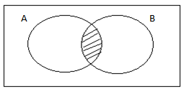

The shaded portion represents A ∩ B.

NB:

1). If A ∩ B = { }, i.e. if the intersection of the sets A and B is equal to the empty set, then A and B are disjointed sets.

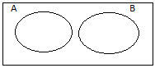i.e.

2).If A ∩ B ≠ ∅ i.e. if the intersection of A and B is not equal to the null set, then A and B are jointed sets.

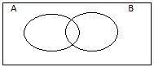

**Q1.** If A = {1,2,3,4} and B = {2,3,7,10}, find A ∩ B. . Soln

A ∩ B = {1,2,3,4) ∩ {2,3,7,10} = {2,3}.

**Q2.** If W = { 1,2,3,4} and X={2,3,7,8}, find W ∩ X. . Soln W ∩ X = {1,2,3,4} n {2,3,7,8}

= {2, 3}.

**The Union of two sets:**

The union of two sets A and B is written as A U B.

This is made up of the set of those elements, which can be found in either A or B or in both A and B.

Example 1

If A = {1,2,3} and B = {4,5}, then A U B = {1,2,3} U {4,5} = {1,2,3,4,5}.

Example 2

If X = {2,5} and Y= {7,8}, then X U Y = {2,5} U {7,8} = {2,5,7,8}.

**NB:** If a number or a letter appears more than once, it must be represented once.

For example if A= {1,2,3,4} and B = {1,2,6}, then A U B = {1,2,3,4} U {1,2,6} = {1,2,3,4,6}.

Also If X = {a,b,c} and Y = {a,b,g} ⇒ X U Y = {a,b,c} u {a,b,g} = {a,b,c,g}.

**NB**

If A = {1,2,3} and B = { }, then A U B={ 1,2,3} U { } = {1,2,3}.

Also If X = {a,b} and Y = { } ⇒ X U Y = {a,b} U { } = {a,b}.

**REPRESENTATION OF A U B ON VENN DIAGRAM:**

(1)

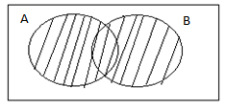

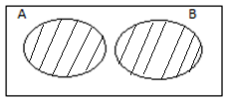(ii)

The shaded portion in each of these diagrams represents A U B.

**The Complement:**

The complement of a set A is written as A’.

This consists of the set of only those elements, which are not found in the set A, but can be found in the universal set.

Example 1

If U = {1,2,3} and A= {2}, then A’= {1,3}.

Example 2 If U = {1,2,3,4,5} and B = {1,5}, then B’= {2,3,4}.

Q1.If A = {1,2,3} and B = {2,4,8}, evaluate the following:

a). A ∩ B b). A U B c). (A U B) ∩ B d).(A ∩ B ) ∩ A e).(A ∩ B) ∩ (A U B).

Soln.

A = {1,2,3} and B = {2,4,8}

a). A ∩ B = {1,2,3} ∩ {2,4,8} = {2}.

b). AUB = {1,2,3} U {2,4,8} = {1,2,3,4,8}. c). (A U B) ∩ B = {1,2,3,4,8}∩{2,4,8} ={2,4,8}.

d). (A ∩ B) ∩ B = {2} ∩{2, 4, 8} = {2}.

e). (A ∩ B) ∩ (A U B) = {2} ∩ {1,2,3,4,8} = {2}.

Q2 Give that X = {1,2,3,4,5} and Y = {3,5,8,10}, evaluate a. X ∩ Y b. X U Y

c. (X ∩Y) ∩ (X U Y) d. (X ∩Y) ∩ X

Soln

X={1,2,3,4,5} and Y={3,5,8,10}. a) X∩Y={1,2,3,4,5} ∩ {3,5,8,10} = {3,5}. b) X U Y ={1,2,3,4,5} U {3,5,8,10} = {1,2,3,4,5,8,10}. c) (X∩Y) ∩ (X U Y) = {3,5} ∩ {1,2,3,4,5} ={3,5, }. d) (X∩Y)U X = {3,5} ∩ {1,2,3,4,5} = {3,5}.

Q3. Give that the universal set U = {1,2,3,4}, A = {1,2} and B = {2,4}, evaluate, the following: a) A’ ∩ B’ b) (A ∩ B)’ c) (A U B)’ ∩ (A ∩ B)’

Soln

U = {1,2,3,4}.

A = {1,2} =>A’= {3,4}. Also B = {2,4} => B’={1,3}.

a) A’∩ B’ = {3,4} ∩ {1,3} = {3}. b) A ∩ B = {1,2} ∩ {2,4} = {2}

=> (A ∩ B)’ = {1, 3, 4}

c) A U B = {1,2} U {2,4} = {1,2,4} => (AUB)’ = {3}, => (A U B)’ ∩(A ∩ B)’= {3} ∩ {1,3,4} = {3}.

Q4 If U = {1,2,3,4,5}, X = {1,2} and Y = {2,4,5}, evaluate

i) X ∩ {X U Y} ii) Y’∩{X∩Y}’

iii) {X ∩ Y}’ ∩{X’ U Y}

Soln

U = {1,2,3,4,5}. Since X= {1, 2} => X’= {3, 4, 5}. And since Y= {2,4,5} => Y’={1,3}.

X U Y = {1,2} U {2,4,5} = { 1,2,4,5}.

X ∩ (X U Y) = {1,2} ∩ {1,2,4,5} = {1,2}.

ii. X ∩ Y= {1,2} ∩ { 2,4,5} = {2}, => (X ∩ Y)’ = {1,3,4,5}. Y’∩(X ∩ Y)’ = {1,3} ∩ {1,3,4,5} = {1,3}.

iii. X’ U Y= {3, 4, 5} U {3, 4, 5} = {2, 3, 4, 5} => (X ∩Y)’ ∩ (X’ U Y) = {1,3,4,5,} ∩ {2,3,4,5} = {3,4,5}.

Q5.Given that X = {Odd numbers greater than 3, but less than 12} and Y = {Prime numbers greater than 2, but less than 12}, evaluate the following: i) X ∩ Y ii. (X ∩ Y) U X iii. (X U Y) ∩ Y iv. (X U Y) ∩ (X ∩ Y).

Soln

X = { 5,7,9,11} and Y= {3,5,7,11}. i). X ∩ Y = {5,7,9,11} ∩ {3,5,7, 9, 11} = {5,7,11}. ii) (X ∩ Y) U X = {5,7,11} U {5,7,9,11} = {5,7,9, 11}. iii) X U Y={5,7,9,11} U {3,5,7,11} = {3,5,7,9,11}, ⇒{X U Y) ∩ Y = {3,5,7,9,11} ∩ {3, 5,7,11} = {3,5,7,11}. iv) (X U Y) ∩ (X ∩ Y) = { 3,5,7,9,11} ∩ (5,7,11} = {5,7,11}.

Q6. If X = {Prime factors of 18} and Y = {Odd multiples of 3 less than 20}, evaluate

i) X ∩ ( Y ∩ X) ii) (X ∩ Y) U (X U Y) iii) (X U Y) ∩ (X ∩ Y).

N/B: X ∩ Y is the same as Y ∩ X. Also Y U X is the same as X U Y..

Soln

Factors of 18 = { 1,2,3,6,9,18} but since X = {Prime factors of 18}, we select only the prime numbers ⇒ x = {2,3}. Also multiples of 3 less than 20 = { 3,6,9,12,15,18} but since Y= { Odd multiples of 3 less than 20}, we select only the odd numbers among them ⇒ Y= {3,9,15}. i) (Y ∩ X) = {3,9,15} ∩ {2,3} = {3}, ⇒ X ∩ (Y ∩ X) = {2,3} ∩ {3} = {3}. ii)(X U Y) = {2,3} U {3,9,15} = {2, 3, 9, 15}⇒ (X ∩Y) U (X U Y) = {3} U {2,3,9,15} = {2,3,9,15} = {2, 3, 9, 15}.

iii) ( X U Y) ∩ (X∩Y) = {2,3,9,15} ∩ {3} = {3}.

Q7Give that U = {Natural numbers from 2 to 8}, A = {Multiples of 2 less than 7} and B = {Factors of 6 less than 8}, evaluate

a)A ∩ B b) A’∩ B c) (A ∩ B)’ U (A’∩B’)

soln

U = {2,3,4,5,6,7,8}. Since .A = {2,4,6} ⇒ A’= {3,5,7,8}.Since B = {2,3} ⇒ B’= {4,5,6,7,8}. a. A ∩ B = {2,4,6} ∩ {2,3} = {2}. b. A’∩ B = {3,5,7,8} ∩ {2,3} = {3}.

c. A ∩ B = {2} ⇒ {A ∩ B}’ = {3,4,5,6,7,8}. A’∩ B’ = {3,5,7,8} ∩ {4,5,6,7,8} = {5,7,8}, ⇒ (A ∩ B)’ U (A’ ∩ B’) = {3,4,5,6,7,8} U {5,7,8} = {3,4,5,6,7,8}.

Q8 Given that N = {x: 3≤ x ⋖ 8} and M = {x: 5 $<x<10\}$, evaluate

i. N ∩ M ii. (N U M) ∩ (N ∩ M)

Soln.

N = {x :3 ≤ x⋖ 8} ⇒ N = {3,4,5,6,7}. M = {x: 5 $<x<10$} ⇒ M = {6,7,8,9}.

i. N ∩ M= {3,4,5,6,7} ∩ {6,7,8,9} = {6,7}. ii. N U M ={3,4,5,6,7} U {6,7,8,9} = {3,4,5,6,7,8,9} , ⇒ (N U M) ∩ (N ∩ M) = {3,4,5,6,7, 8, 9} ∩ {6,7} = {6,7).

Q9. You are given the following sets: X = { n: 2 ≤ n ≤ 8, where n is an even number} and Y = {n: 3 $<$ n ≤ 44, where n is a prime number}. Evaluate i) X ∩ Y ii) X U Y} iii) (X ∩ Y) U (X U Y).

**NB:** {2 ≤ x ≤ 8} ⇒ the members are {2,34,5,6,7,8} but since n is an even number, we only consider the even numbers => X={2,4,6,8}.

Also {n: 3 ⋖ n ≤ 11} = {4,5,6,7,8,9,10,11}, but since n is a prime number we select only the prime numbers among them ⇒ Y = {5,7,11}.

Soln

i. X ∩ Y = {2,4,6,8} ∩ {5,7,11}= { }. ii. X U Y = {2,4,6,8} U {5,7,11} = {2,4,5,6,7,8,11}. iii. (X∩Y) U {X U Y} = { } U {2,4,5,6,7,8,11} = {2,4,5,6,7,8,11}.

Q10 If A = {x: 2 ≤ x ⋖ 10, where x is a factor of 8} and B = {x:1 ≤ x ≤ 10, where x is a composite number}, evaluate

i., A ∩ B ii. (A U B) ∩ A iii. (A U B) ∩ (A ∩ B)

**NB:** The members of {x: 2 ≤ x ⋖ 10} = {2,3,4,5,6,7,8,9} but since x is a factor of 8, we select only the factors of 8 ⇒ A = {2,4,8}. Also B = {x:1 ≤ x ≤ 10} = {1,2,3,4,5,6,7,8,9,10} but since x is a composite number, we select only the composite numbers among them ⇒ B = {4,6,8,9,10}.

Soln

A = {2,4,8} and B = {4,6,8,9,10}.

i. A ∩ B = {2,4,8} ∩ {4,6,8,9,10} = {4,8}. ii. (A ∩ B)∩A= {4,8} ∩ {2,4,8} = {4,8}.

iii. A U B = {2,4,8} U {4,6,8,9,10} = {2,4,6,8,9,10}.

(A U B) ∩ (A ∩ B) = {2,4,6,8,9,10} ∩ {4,8} = {4,8}.

**RELATIONSHIP BETWEEN UNIVERSAL SETS AND THEIR SUBSETS, AND THEIR REPRESENTATION ON VENN DIAGRAMS.**

**-** The main relationship between a universal set and its various subsets is that, all the members of the subset must also be members of the universal set.

- With reference to this sub topic, it is important for one to be in position to be able to identify jointed as well as disjointed sets, and how to illustrate them on Venn diagrams, when their members are given.

Q1.If x = {1,2,3,4,5} and Y ={2,3,6,7,8}, represent X and Y on a Venn diagram. **NB:** Since X and Y contain some common items ie 2 and 3, then they are jointed sets.

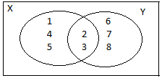 Soln

**NB:** The common items are always found in the region where the two sets overlap.

Q2 If X = {2,3} and Y= {4,5}, represent X and Y on a Venn diagram. **NB:** Since X and Y do not contain any element in common, then they are disjointed or separated sets.

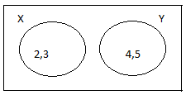 Soln

Q3 If R = {a,b,c,d} and K = {b,g,h}, represent R and K on a Venn diagram

Soln

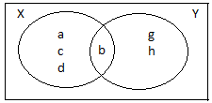

o

Q4:

(4) If A = {a,b,c} and B = {d,e}, represent A and B on a Venn diagram.

Soln

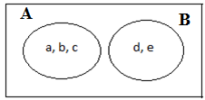

Q5: The universal set U = {0,1,2,3,4, 5, 6, 7}, X = {1, 2, 3, 4} and Y= {3,4,6}. Represent U, X and Y on a Venn diagram.

Soln

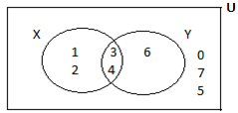

**NB:**  Those elements which are not found within X and Y, but are within the universal set i.e. 0,5 and 7 should be found outside X and Y but within U, as shown in the given diagram.

Q6. The universal set U = {a,b,c,d,e,f,g,h}. If A = {a, b} and B = {b,e}, represent U,A and B on a Venn diagram.

Soln

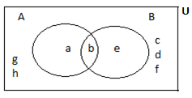

Q7: If U = {a,b,c,d,e,f,g}, X = {a,b,c} and Y = {d,e}, represent U,X, and Y on a Venn diagram, given that U is the universal set.

Soln

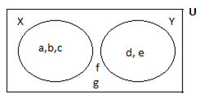

Q8: The universal set U = {1,2,3,…………6}. If A = {2,3} and B = {4,5}, illustrate U, A and B on a Venn diagram.

Soln

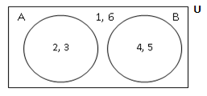

Q9: The universal set U = {Counting numbers less than 11}. The sets P and Q are subsets of U, such that P = {Prime factors of 6} and Q = {Even numbers greater or equal to 4}.

a. List the members of U, P and Q.

b. Illustrate U, P and Q on a Venn diagram.

Soln

U = {1, 2, 3, 4, 5, 6, 7, 8, 9, 10}

Factors of 6 = {1, 2, 3, 6}

=> P = {Prime factors of 6} = {2,3}

i.e. Select only the prime numbers.

Q = {even numbers greater than or equal to 4}

=> Q = {4, 6, 8, 10, 12, 14, 16…………}

But since P and Q are subsets of U, then all the members of P and Q must also be found within the universal set

=> Real Q = {4, 6, 8, 10}.

Now P = {2, 3,} and real Q = {4, 6, 8, 10}

=> P and Q are disjointed sets since they have no common element or elements.

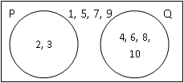

Q10: The universal set *U* = {even numbers less than 14}. *X* and *Y* are subsets of *U*. *X* = {whole numbers less than 14} and *Y* = {factors of 18}.

a. List the members of *U*, *X* and *Y*.

b. Represent *U*, *X* and *Y* on a Venn diagram.

Soln

**NB:** U = {2, 4, 6, 8, 10, 12}.

*X* = {whole numbers less than 14}.

*=> X* should have been {0, 1, 2, 3, 4, 5, 6, 7, 8, 9, 10, 11, 12, 13}, but since *X* is a subset of U, then all the member of *X* must also be members of *U =>*X = {2, 4, 6, 8, 10, 12} i.e. real *X.*

Also, *Y* = {factors of 18}. *Y* should have been {1, 2, 3, 6, 9, 18}, but since *Y* is a subset of *U*, we select only those numbers which can also be found in the universal set *U*,=>Y = {2, 6} i.e. real *Y*.

Now *U* = {2, 4, 6, 8, 10, 12}.

*X* = {2, 4, 6, 8, 10, 12}.

Y = {2, 6}.

*X* and *Y* are jointed sets, since they contain a common item which is 2.

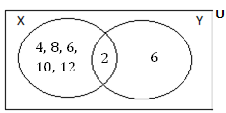

Q11: *M* is a set consisting of all positive integers between 1 and 10. *P* and *Q* are subsets of *M* such that *P* = {factors of 6} and *Q* = {multiples of 2}.

i. List the elements of *M, P* and *Q*.

ii. Represent *M*, *P* and *Q* on a Venn diagram.

iii. Find P ∩ Q. Soln

i. *M* = {1, 2, 3, 4, 5, 6, 7, 8, 9, 10}

*P* = {1, 2, 3, 6} and Q should have been given by Q = {2, 4, 6, 8, 10, 12, 14………}, but since P and Q are subsets of M, then all the members of P and Q must also be members of M => Q = {2, 4, 6, 8, 10}.

ii.

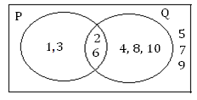

iii. P $∩$ Q = {1, 2, 3, 6} $∩$ {2, 4, 6, 8, 10}

= {2,6}

Q12:The universal set U = { $x:-2≤x≤10$ where $x$ is an even number}. P and Q are subsets of U where P = $\{x:x$ is a multiple of 2 less than 6} and Q = $\{x:x$ is an odd number}.

i. Represent U, P and Q on a Venn diagram.

ii. Determine P $∩$ Q.

**NB:** The universal set U should have been {-2, -1, 0, 1, 2, 3, 4, 5, 6, 7, 8, 9, 10}, but since U = $\{x:-2≤x≤10$, where $x$ is an even number, we select only the even numbers among them=> U = {2, 4, 6, 8, 10}.

Also, P = $\{x:x$ is a factor of 6} should have been P = {1, 2, 3, 6}, but since P is a subset of the universal set U => all members of P must also be members of U,=> P = {2, 6}. Lastly, Q = {multiples of 2 less than 6} = {2, 4}.

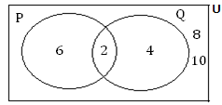

ii. P $∩$ Q = {2,6} $∩$ {2,4} = {2}

Q13:The universal set $ε$ = {x: 2 ≤ x ≤ 10, where x is an even number}. P and Q are subsets of $ε$ such that P = { $x:x$ is a factor of 12 less than 5}, and Q = {even numbers greater than or equal to 6}. Represent $ε$, P and Q on a Venn diagram.

**Soln**

**NB:**The universal set $ε$ should have been {2, 3, 4, 5, 6, 7, 8, 9, 10}, but since $x$ is an even number => $ε$ = {2, 4, 6, 8, 10}.

P = {factors of 12 less than 5} should have been given by P = {1, 2, 3, 4}, but since P is a subset of $ε=>$ P = {2,4} since all the members of P must also be members of $ε.$

Lastly, Q = {even numbers greater than or equal to 6}, should have been given by Q = {6, 8, 10, 12, 14 ………}, but since Q is a subset of $ε$, all members of Q must also be members of $ε=>$ Q = {6, 8, 10}..

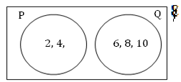

Q14: The sets A and B are subsets of the universal set U = {$x:5x-1>3x+5$, where $x$ is an odd number less than 22}.

A = {multiples of 3} and B = {Prime factors of 21}.

a. List the members of U, A and B.

b. Represent U, A and B on a Venn diagram.

**Soln**

Simplify the inequality $5x-1>3x$ +5, => $5x-3x>5+1=>2x>6x,$ => x > $\frac{6}{2}=>x>3∴$ U = {$x:5x-1>3x+5$, where $x$ is an odd number less than 22},=> U = {$x:x>3$, where $x$ is an odd number less than 22}. U should have been {4, 5, 6, 7, 8, 9…………… 21}, but since $x$ is an odd number, select the odd numbers among them, => U = {5, 7, 9, 11, 13, 15, 17, 19, 21}.

A = {multiples of 3} should have been given by A = {3, 6, 9, 12, 15, 18, 21, 24 ………}, but since A is a subset of U, we only choose those members which are also members of U => A= {9, 15, 21}, i.e. real A.

B = {Prime factors of 21}.

Factors of 21 = {1, 3, 7, 21}.

For these prime factors of 21, select only the prime numbers among them. Therefore, B should have been given by {3, 7}, but also since B is a subset of U, all members of B must be members of U.

=> B = {7} i.e. real B.

Also, A $∩$ B = {9, 15, 21} $∩$ {7} = $∅$

=> A and B are disjointed sets.

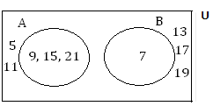

Q15: The universal set U = {$x:\frac{1}{2}x-2≥1$, where $x$ is an even number less than 20}. A and B are the subsets of U, where A= {factors of 18} and B={composite multiples of 3}.

a. List the elements of U, A and B.

b. Illustrate U, A and B on a Venn diagram.

Soln

U = {$x:\frac{1}{2}x-2≥1$, where $x$ is an even number less than 20}.

Consider $\frac{1}{2}x-2≥1$.

Multiply through using 2 => $2×\frac{1}{2}x-2×2≥2×1$

$=>x-4≥2=>x≥2+4,=>x≥6=>$ U = {$x:x≥6$, where $x$ is an even number less than 20}.

U should have been given by {6, 7, 8, 9…….}.

But since x is an even number less than 20, we select all the even numbers from 6 to 19, => x = (6, 8, 10, 12, 14, 16, 18}.

A = {factors of 18}.

A should have been given by {1, 2, 3, 6, 9, 18}, but since A is a subset of U, we only select those members of A which are also members of U.

=>A = {6, 18} i.e. real A.

B = {composite multiples of 3}.

Multiples of 3 = {3, 6, 9, 12,15 ………….....}.

For the composite multiples, we select only those members which are composite members.

B should therefore have been given by {6, 9, 12, 15, 18, 21, 24 ……………}, but since B is a subset of U, we select only those members which are also member of U.

⇒ B = {6,12,18}.

A ∩ B = {6,18} ∩ {6,12,18} = {6,18}  
⇒ A and B are jointed sets.

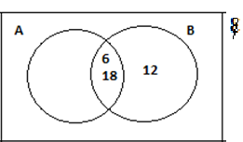

Q16: The sets X,Y and Z are subsets of the universal set U, where U = {x:x is an even number less than 14}.

X = {Even multiples of 2}.

Y= {x: 3x – 1 $>11\}.$

Z= {x: x $≥3, where x is a$ composite number}

Evaluate

i) X ∩ Y ii). (X U Z) ∩ Y

iii) (X ∩ Y)’ ∩ (Z ∩ Y) iv) (X’∩ Y’) U (Y ∩ Y)

Soln

U = {x:x is an even number less than 14},

⇒ U = {2,4,6,8,10,12}.

X = {Even multiples of 2}

= {2,4,6,8,10,12,14 …………….}.

For all multiples of 2 are even numbers.

But since X is a subset of U, then all members of X must also be members of U,

⇒ X = {2,4,6,8,10,12} i.e. real X.

3x – 1 $>$ 11 ⇒ 3x $>$ 12, ⇒ x $>\frac{12}{3}$ => x $>$ 4

.:. Y= {x: x $>$ 4} ,

=> Y= {5,6,7,8 ……………..} but since Y is a subset of U, then Y= {6,8,10,12} i.e. real Y, since all the members of Y must also be members of U.

Z = {x :x $>$ 3, where x is a composite number} .

Z should have been given by z = {4,6,8,9,10,12,13,14,15,16………..}, but since Z is a subset of U, then all the members of Z must also be members of U ⇒ real Z = {4,6,8,10,12}.

i) X ∩ Y= {2,4,6,8,10,12} ∩ {6,8,10,12} = {6,8,10,12}

ii) X U Z = {2,4,6,8,10,12} U {4,6,8,10,12} = {2,4,6,8,10,12},

⇒ (X U Z) ∩ Y= {2,4,6,8,10,12} ∩ {6,8,10,12}

= {6,8,10,12}.

iii) X ∩ Y = {6,8,10,12}

⇒ (X ∩ Y)’ = (2,4},

⇒ (X ∩ Y)’ ∩ (X ∩ Y)

= {2,4} ∩ {6,8,10,12} = { }.

iv) X = {2,4,6,8,10,12}

⇒ x’ = { }.

Z = {4,6,8,10,12}

⇒ Z’= {2}.

X’ ∩ Z’ = { } ∩ {2} = { },

.:. (x’∩ z’) U (Y∩X) = { } U {6,8,10,12} = {6,8,10,12}.

Q17 The sets A = {x:x is a prime number} and B = {x:x is an even number} are subsets of the universal set U = { 1,2,3,4,5,6,7}.

Evaluate:

i. A ∩ B ii) (A ∩ B)’

iii) (A U B) n A’ iv) (A’∩ B’) ∩ A’

iv) (A’ U B’) U {A’∩ B’}

Soln

A = {x:x is a prime number}. A should have be given by A= {2,3,5,7,11, ………. } but since A is a subset of U, then A = {2,3,5,7}.

B = {x:x is an even number}.

B should have been given by B =

{2,4,6,8,10,12, ……..}, but since B is a subset of U, then B = {2,4,6} i.e real B, since all the members of B must also be members of U.

From A = {2,3,5,7} ⇒ A’={1,4,6} and also B = {2,4,6} ⇒ B’={1,3,5,7}

i) A ∩ B = {2,3,5,7} ∩ {2,4,6} = {2}

ii) (A n B)’ = {1,34,5,6,7}

iii) A U B = (2,3,4,5,6,7}

⇒ (A U B) ∩ A’= {2,34,5,6,7} ∩ {1,4,6} = {4,6}.

iv) A’∩ B’= {1,4,6} ∩ {1, 3, 5,7} = {1}.

(A’∩ B’) ∩ A’ = {1} ∩ (1, 4, 6) = {1}.

(v) A’ U B’ = {1, 4, 6} U {1, 3, 5, 7}

= {1, 3, 4, 5, 6, 7}.

A’∩ B = {1, 4, 6} ∩ {2, 4, 6} = { }.

(A’ U B’} U (A’∩ B) = {1, 3, 4, 5, 6, 7} U { }

= {1, 3, 4, 5, 6, 7}.

**Two Set Problems:**

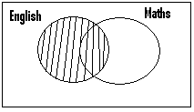

The shaded part represents those who study English.

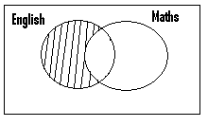

The shaded part represents those who study only English or English only.

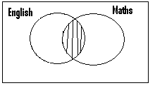

The shaded part represents those who study both English and Maths.

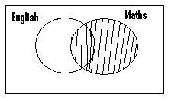

The shaded part represents those who study Maths.

The shaded part represents those who study only Maths or Maths only.

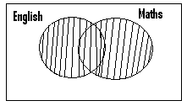

The shaded part represents those who study Maths or English or both.

Example.

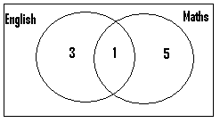

Number of those who study only English = 3. Number of those who study English = 3 + 1 = 4. Number of those who study both English and Maths = 1. Number of those who study Maths = 1 + 5 = 6. Number of those who study Math only or only Maths = 5.

Q1) In a class, 30 students study Maths or English or both.5 study both subjects while 10 study only Maths. Find the number of those who study

1. only English (b) English

Soln.

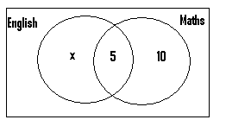

Let x = number of those who study only English.

Since 30 students study English or Maths or both

⇒ x + 5 + 10 = 30 ⇒ x + 15 = 30

∴ x = 30 – 15 = 15.

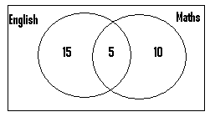

Number of those who study English only or only English = 15.

Number of those who study English = 15 + 5 = 20.

Q2) Out of the 90 people who attended a party, 20 did not take in beer or fanta. With respect to those who took in beer or fanta, 20 took in only fanta and 40 took in beer only.

1. Represent this on a Venn diagram.
2. Find the number of those who took in

i) both fanta and beer.

ii) beer

iii) fanta.

Soln.

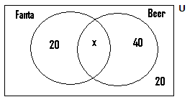

Let x = the number of those who took in both beer and fanta.

Since 20 people out of the 90 people did not take in beer or fanta ⇒

The number of those who took in beer or fanta or both = 90 – 20 = 70,

⇒ with reference to the Venn diagram, then 20 + x + 40 = 70

⇒ 60 + x = 70 ⇒ x = 70 – 60

⇒ x = 10.

The Venn diagram drawn then becomes as shown next:

(a)

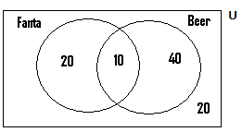

(b)(i) The number of those who took in both fanta and beer = 10.

(ii) Number of those who took in beer = 10 + 40 = 50.

(iii)Number of those who took in fanta = 20 + 10 = 30.

Q3) Out of the 20 candidates who wrote an examination, 17 passed in either General Science or Social Studies altogether and 5 passed in only General Science, whilst 7 passed in General Science. Find the number of those who passed in

1. social Studies.
2. social Studies only.

N/B:

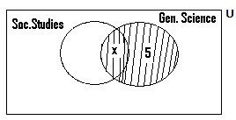

Since 7 passed in Gen. Science, then the total number of those within the shaded part = 7.

⇒ x + 5 = 7 ⇒ x = 7 – 5 ⇒ x = 2.

Soln.

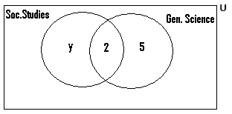

Let y = the number of those who passed in Social Studies only. Then since 17 passed in either Gen. Science or Social Studies altogether ⇒ y + 2 + 5 = 17 ⇒ y + 7 = 17,

⇒ y = 17 – 7 ⇒ y = 10.

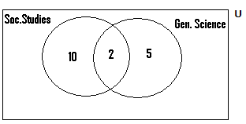

N/B: n(u) = 20, since 20 candidates wrote the exams.

1. n(those who passed in Social Studies) = 10 + 2 = 12.
2. n(those who passed in Social Studies only) = 10.

Q4) One day, 93 students were supposed to take an examination. Of these, 56 took the history paper in the morning and 59 took the Geography paper in the afternoon. If 8 students took only the history paper,

1. how many took the Geography but did not take the History paper?
2. how many students refused or failed to write the examination?

Soln.

n(Students supposed to take the exams) = 93.

n(History candidates) = 56.

n(only History candidates) = 8.

n(Geography candidates) = 59

N/B:

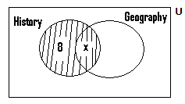

The shaded portion represents the number of those who took the history paper. Since 56 candidates took the History paper, then 8 + x = 56 ⇒ x = 56 – 8 = 48.

Soln.

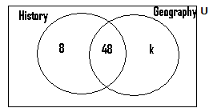

Let k = the number of those who took Geography only.

Since 59 candidates wrote the Geography paper, then k + 48 = 59

⇒ k = 59 – 48 = 11.

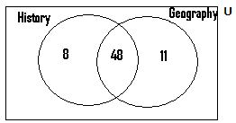

n(those who took the Geography but not the History paper) = n(those who took only Geography) = 11.

1. Total number of candidates supposed to write the examination = 93.
2. Total number of those who took the examination = 8 + 48 + 11 = 67.

⇒ n(those who failed or refused to write the exams) = 93 – 67 = 26.

Q5) There are 100 students in a school and out of this number, one quarter eat beans or rice or both. 4 students eat only beans and a student eat both rice and beans.

1. Represent this on a Venn diagram.
2. How many students eat rice?

Soln a).

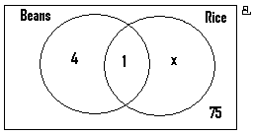

Let x = the number of those who eat rice only.

n(those who eat beans or rice or both) = $\frac{1}{4}×100=25.$

Since 25 people eat beans or rice or both, then 4 + 1 + x = 25

⇒ 5 + x = 25 ⇒ x = 25 - 5

⇒ x = 20.

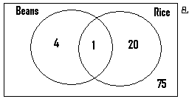

(b)n(those who eat rice) = 1 + 20 = 21.

N/B:

Since 25 students out of the 100 students eat rice ⇒ the number of those who do not eat rice or beans or both = 100 – 25 = 75 students.

These 75 students must be found within the universal set, but outside the two sets under consideration.

The universal set β = 100, since there are 100 students in the school.

Q6) A survey was conducted on 60 children, to determine the effectiveness of a preventive drug against measles and malaria in children. It came out that the same number of children suffered from only one type of the two diseases and 4 suffered from both diseases. If 36 of the children were not attacked by any of these two diseases, find the number which suffered from

1. only measles.
2. malaria.

Soln.

n(children used for the test) = 60

n(children who were not attacked by the two diseases) = 36

⇒n(children who were attacked by the two diseases) = 60 – 36 = 24

n(those who suffered from both diseases) = 4.

Also the number of those who suffered from only one type of the two diseases (i.e measles only or malaria only) is the same.

Let this number = x.

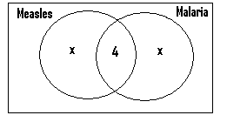

Since n(those who were attacked by either measles or malaria or both diseases) = 24

⇒ x + 4 + x = 24

⇒ 2x + 4 = 24 ⇒ 2x = 24 - 4

⇒2x = 20 ⇒ x = $\frac{20}{2}=10$

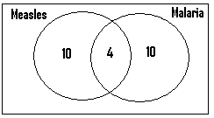

1. n(those who suffer from only measles) = 10.
2. n(those who suffer from malaria) = 4 + 10 = 14 children.

Q7) Out of the 200 candidates who wrote an examination, $\frac{3}{5}$ did not write the Geography or the History paper. Out of those who took these papers, $\frac{1}{4}$ wrote only the Geography paper and 40% wrote only the History paper. How many wrote

1. both papers?
2. the History paper?

Soln.

n(those who did not write the Geography paper or the History paper) = $\frac{3}{5}×200$ = 120

=> n(those who wrote these two papers) = 200 – 120 = 80.

⇒n(those who took only the Geography paper) = $\frac{1}{4}×80$ = 20.

n(those who took only the History paper) = 40% of 80

= $\frac{40}{100}×80 = 32.$

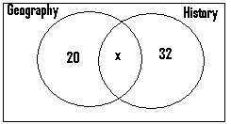

Let x = the number of those who took both subjects or papers.

Since 80 candidates wrote the Geography and the History papers altogether, then 20 + x + 32 = 80 ⇒52 + x = 80

⇒ x = 80 – 52 = 28

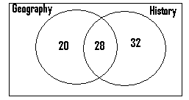

1. n(those who wrote both papers) = 28.
2. n(those who wrote the history paper) = 28 + 32 = 60.

N/B:

n(those who wrote the History and the Geography paper) = 20 + 28 + 32 = 70.

This refers to the total number of those who wrote only History or only Geography or both.

But n(those who wrote both the History and the Geography papers) = 28.

Q8) In a certain hospital, out of 200 patients tested, 120 were found to be suffering from malaria or typhoid or both. Out of these 120 patients, 30% suffered from only malaria and $\frac{1}{4}$ suffered from only typhoid. Find the number of those who were suffering from

both diseases (b) typhoid.

Soln.

n(those suffering from only malaria) = 30% of 120 = $\frac{30}{100}x120$ = 48

n(those suffering from only typhoid) = $\frac{1}{4}×120$ = 30.

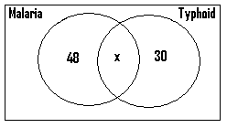

Let x = the number of those who were suffering from both diseases.

Since 120 patients were suffering from malaria or typhoid or both, then 48 + x + 30 = 120

⇒ 78 + x = 120 ⇒ x = 120 – 78

⇒ x = 42.

n(those who were suffering from both diseases) = 42.

n(those who were suffering from typhoid) = 42 + 30 = 72

Q9) Out of the 25 people within a class, $\frac{1}{5}$ do not offer Physics or Chemistry or both. 5 offer both subjects but the number of those who offer Chemistry only is twice that of those who offer Physics only. How many offer

1. Chemistry? (ii) Physics?

Soln.

Let x = the number of those who offer only Physics, then the number of those who offer Chemistry only = 2x.

n(those who do not offer any of these two subjects) = $\frac{1}{5}×25$ = 5 ⇒ the number of those offering these two subjects = 25 – 5 = 20.

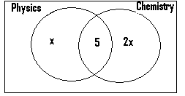

Since 20 offer Physics or Chemistry or both, then x + 5 + 2x = 20

⇒ 3x + 5 = 20 ⇒ 3x = 20 – 5

⇒ 3x = 15 ⇒ x = $\frac{15}{3}=5$

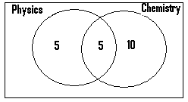

1. n(those who study Chemistry) = 10 + 5 = 15.

ii) n(those who study Physics) = 5 + 5 = 10.

Q10. The sets A={1,2}, B = {2,3,4} and C = {5, 6} are the subsets of and the universal set U = {1,2,…….8}. Represent this on a Venn diagram.

Soln.

A n B = {1,2} n {2,3,4} = {2} ⇒A and B are jointed sets.

A n C= {1,2} n {5,6} = $∅$ ⇒A and C are disjointed sets.

Lastly B n C= {2,3,4}∩{5,6} = $∅,$ ⇒ B and C are disjointed sets.

U = {1,2,3,4,5,6,7,8}.

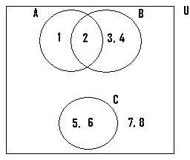

Q11) The sets A = {1.2}, B = {3,4} and C = {7, 8} are the subsets of the set M = {1,2,3,4,7,8,10,13}. Illustrate this on a Venn diagram.

Soln.

A n B = {1,2} n {3,4} = $∅$ ⇒ A and B are disjointed sets.

A n C = {1,2} n {7,8} = $∅$ ⇒ A and C are disjointed sets.

B n C = {3,4} n {7,8} = $∅$ ⇒ B and C are disjointed sets.

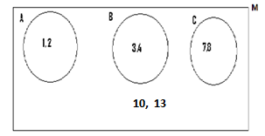

Q12) In an interview, 16 people said they liked football or boxing or both. Of this number, 10 liked football and 8 liked boxing. Find the number of those who like

1. both football and boxing.
2. only football.
3. only boxing.

N/B: (1)

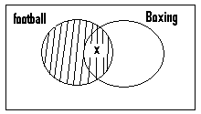

Let x = the number of these who like both football and boxing.

(2) Since 10 people like football, then the total number of those within the shaded portion = 10.

Since x 0f them occupy one part of this shaded portion, then the rest i.e (10 – x) must occupy the other portion as shown in the next figure

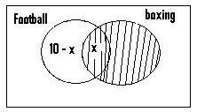

Also 8 people like boxing, ⇒ the number of those to be found within the shaded portion = 8.

Since x of them occupy one part, then the rest i.e (8 – x) must occupy the other portion as shown in the next diagram.

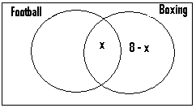

Soln.

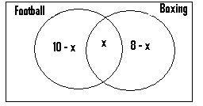

Let x = the number of those who like both football and boxing.

Since 16 people liked football or boxing or both ⇒ 10 – x + x + 8 – x = 16,

⇒ 18 – x = 16 ⇒ 18 – 16 = x , ⇒ x = 2.

The Venn diagram therefore becomes as shown next:

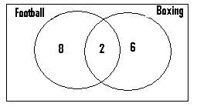

1. Number of those who like both football and boxing = 2.
2. Number of those who like only football = 8
3. Number of those who like only boxing = 6.

Q13) Out of the 25 students in a class, 15 do not offer Physics or Chemistry or both. If 7 offer Chemistry and 5 offer Physics, find the number of those who offer

1. both subjects. (b) Physics only. (c) Chemistry only.

Soln.

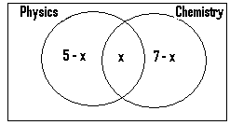

Let x = the number of those who offer both subjects.

Since 5 offer physics ⇒ the number of those who offer Physics only = 5 – x.

Also since 7 offer Chemistry ⇒ the number of those offering only Chemistry = 7 – x.

Lastly, 15 students out of the 25 students do not offer Physics or Chemistry or both

⇒ the number of those offering Physics or Chemistry or both = 25 – 15 = 10,

∴ 5 – x + x + 7 – x = 10.

Since –x + x = 0, then

5 + 7 – x = 10,

⇒ 12 – x = 10 ⇒ 12 – 10 = x,

⇒ x = 2.

The diagram becomes

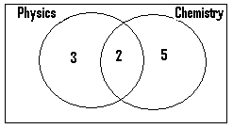

1. n(those who offer both subjects) = 2.
2. n(those who offer only Physics) = 3.
3. n(those who offer only Chemistry) = 5.

Q14) One day, 200 patients visited a clinic, and 20% were found to be suffering from malaria or typhoid or both. If 30 patients were suffering from typhoid and 15 were suffering from malaria, find the number of those who were suffering from

1. both diseases. (b) only malaria. (c) only typhoid.

Soln.

n(those who suffered from malaria or typhoid or both) = 20% of 200 = $\frac{20}{100}×200$ = 40 patients.

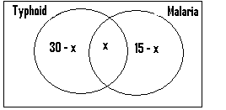

Let x = number of those who were suffering from both diseases.

Since 30 patients were suffering from typhoid ⇒ the number of those who suffered from typhoid only = 30 – x .

Also since 15 patients were suffering from malaria ⇒ the number of those who were suffering from malaria only = 15 – x.

Lastly since 40 people were suffering from typhoid or malaria or both, then

30 – x + x + 15 – x = 40,

⇒ 30 + 15 – x = 40 ⇒ 45 – x = 40,

⇒ 45 – 40 = x ⇒ x = 5.

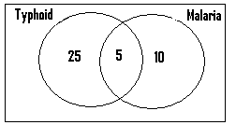

1. n(those who were suffering from both diseases) = 5.
2. n(those who were suffered from malaria only) = 10..
3. n(those who suffered from only typhoid) = 25.

Q15) In a certain school, out of the 50 candidates who wrote an examination, 30% did not write the Maths or the General Science paper. Of these who wrote these papers, 15 wrote the Maths paper and 22 wrote the General Science paper. Find the number of those wrote

1. only the General Science paper.
2. only one subject.
3. only two subjects.

Soln.

The number of those who did not write the General Science or the Maths paper

= 30% of 50 = $\frac{30}{100}×50$

= 15.

⇒ The number of those who wrote these two papers = 50 – 15 = 35.

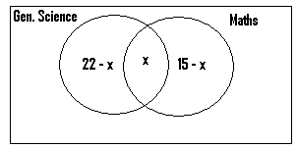

Let x = the number of those who wrote both papers. Then since 35 candidates wrote these two papers, 22 – x + x + 15 – x = 35,

⇒ 22 + 15 – x = 35,

⇒ 37 – x = 35 ⇒ 37 – 35 = x,

⇒ x = 2.

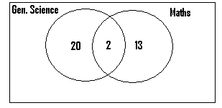

n(those who wrote only the General Science paper) = 20.

n(those who wrote only one paper) = 20 + 13 = 33.

n(those who wrote two papers) = 2.

Q16) In a school, 70% of the students study Science and 40% study French. Each student study at least one of these subjects.

1. Represent this on a Venn diagram.
2. Use it to find the percentage which studies both subjects.

N/B: Since we are dealing in percentages, then the total number of students = 100.

Soln.

n(students who study Science or French or both) = 100.

n(students who study Science) = 70.

n(those who study French) = 40

.

(a)

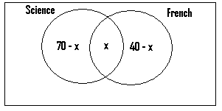

Since the number of those who study Science or French or both = 100

⇒ 70 – x + x + 40 – x = 100 ⇒ 110 – x = 100 ⇒ x = 10

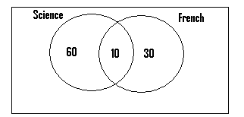

(b)The percentage which study both subjects = 10%.

Q17) In a school, 55% of the students play volleyball and 65% play football. Each students play at least one of these games.

1. Represent this on a Venn diagram.
2. Use it to determine the percentage of those who play

i) both games.

ii) only one game.

Soln.

n(students who play volleyball or football or both) = 100.

n(students who play volleyball) = 55.

n(those who play football) = 65.

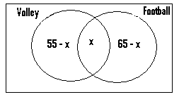

Let x = the percentage or the number of those who play both games.

Since the number of those who play football or volleyball or both = 100, then

55 – x + x + 65 – x = 100,

⇒ 55 + 65 – x = 100

⇒ 120 – x = 100, ⇒ 120 – 100 = x

⇒ x = 20.

(a)

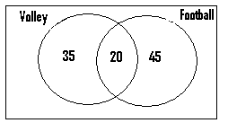

(b)(i) The percentage of those who play both games = 20%.

(ii) The percentage of those who play only one game = 35 + 45 = 80%.

Questions

Q1) Given that A = {a, b , c, d} and B = {c, d, e}, evaluate the following:

A n B Ans: {c, d}

A $∪$ B Ans: {a, b, c, d, e}

(A n B) n A Ans: {c, d}

(A $∪$ B) n (A∩ B) Ans: {c, d}

Q2) Given that X = {1, 2, 3, 4} and Y= {3, 5, 8}, evaluate the following:

X $∪$ Y Ans: {1, 2, 3, 4, 5, 8}

X n Y Ans: {3}

(X $∪$ Y) n Y Ans: {3, 5, 8}

(X n Y) $∪$ (X $∪$ Y) Ans: {1, 2, 3, 4, 5, 8}

(X n Y) n (X $∪$ Y) Ans: {3}

Q3) If the universal set U = {1, 2, 3, 4, 5}, X = {2, 3, 4} and Y = {1, 3, 5}, evaluate

$X^{1}∪Y^{1}$ Ans: {1, 2, 4, 5}

($X^{1}∩Y^{1})∩Y$ Ans: { }

(X n Y) n (X n ${Y)}^{1}$ Ans: { }

($X^{1}∩Y)∪Y$ Ans: {1, 3, 5}

($X^{1}∩X)∩\left(Y^{1}∩Y\right)$ Ans: { }

Q4) You are given the following sets, X = {n: 2 $≤$ ∩ $≤5\}$ and Y= {n: 2 $< ∩ <7\}.$ Find

X n Y Ans: {3, 4, 5}

$\left(X∪Y\right)∩$ Y Ans: {3,4, 5, 6} $\left(X∪Y\right)∩\left(X∩Y\right) Ans:\left\{3, 4, 5\right\}$

Q5) The set A = {factors of 12) and set B = { multiples of 3 less than 15}. Evaluate

A ∩ B Ans: {3, 6, 12} ( A ∩ B) ∩ B Ans: {3, 6, 12}

Q6) X = { Prime factors of 15} and Y = { Odd multiples of 3 less than 14}. Find

X n Y Ans: {3}

(X $∪Y)∪Y Ans:\{3, 5, 9\}$

(X $∪Y)∪\left(X∩Y\right) Ans:\{3, 5, 9\}$

Q7) If X = {x: 2 ≤ x $<10, where x is a factor of 9\},$ and Y = {x: 1 ≤ x ≤ 8, where x is a prime number}, evaluate

X n Y Ans: {3}

(X n Y) n (X $∪$ Y) Ans: {3}

(X n Y) n Y Ans: {3}

Q8) Given the universal set U = {1, 2, 3 ……………,10},

X = {2, 3, 4, 6, 9} and Y= {1, 3, 6, 8}, represent U, X and Y on a Venn diagram.

Ans:

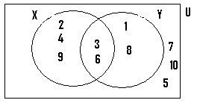

Q9) The universal set U={x: -2 $≤x<12,where x is an integer\}.$ X and Y are subsets of the universal set U. If X = {x: 2x $>4, where x is an even number\},$ and Y = {x: where x is a prime number}, represent U, X and Y on a Venn diagram.

Ans:

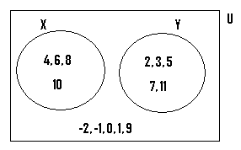

Q10) X and Y are subsets of the universal set

U = {x: 2x + 1 ≥ 5, where x is a composite number less than 15}. If X = {x: x is a factor of 24} and Y = {x: x $>$ 2, where x is an even number},

1. illustrate U, X and Y on a Venn diagram.

Ans:

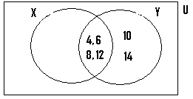

1. List also the members of U, X and Y.

Ans: U = { 4, 6, 8, 9, 10, 12, 14}

X = { 4, 6, 8, 12}

Y = { 4, 6, 8, 10, 12, 14}

(11) The sets X and Y are subsets of the universal set

P = {x: 1 $≤x≤10, where x is an integer\}.$ X = {x: x is a factor of 6}

and Y = {x: x is a multiple of 2}.

Find X n Y Ans: {2,6}

Illustrate U, X and Y on a Venn diagram.

Ans:

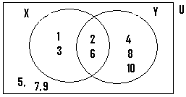

Q12) In a class, 40 students study Physics or Chemistry or both. 12 students study only Physics and 15 study only Chemistry. Determine the number of those who study

both subjects Ans: 13

Physics Ans: 25

Q13) At lunch one hot afternoon, 15 students at a school ate rice or beans or both. If 2 students ate both food items and 5 took in only beans, how many took in (i) only rice Ans: 8 (ii) rice Ans: 10.

Q14) Of the 45 top level workers at a company, 15 were neither managers nor accountants or both. 14 of them were managers and 2 were both managers and accountants. Determine the number of those who were only accountants. Ans: 16

Q15) Of the 80 candidates who wrote an examination, 20% passed in Science and $\frac{2}{5}$ passed in English. Altogether 32 candidates passed in these two subjects. Determine the number of those who passed in

both subjects Ans: 16

only Science Ans: 10

only English Ans: 16

Q16) During an education survey, it came to light that the 12 tutors who taught at a Senior High School were graduates or diplomates or both. If 7 tutors were graduates and 8 were diplomates, how many were

only graduates ? Ans: 4

only diplomates ? Ans: 5

both graduates and diplomates ? Ans: 3

Q17) Out of the 20 pupils in a club, 2 pupils cannot speak Twi or Fanti. or both .If 15 pupils speak Fanti and 4 pupils speak Twi, find the number of those who speak

only Fanti Ans: 14

both languages Ans: 1

Q18) At a language training centre, 80% of the teachers speak French and 40% speak German. If each teacher speaks at least one of these languages, determine the percentage which speak

only French Ans: 60%

both languages Ans: 20%

Q19) Of the 80 traders at a market, 20% were male. With respect to the female traders, 50 sell yam and 20 sell cassava. How many sell

both yam and cassava Ans: 6.

only yam Ans: 44